Patient name: Earl Reed (M)
D.O.B. 04/06/1953
Medicare, 5W23MY7XU96
Public Aid (Illinois Medicaid), 225248376
Blue Cross Blue Shield (BCBS) - Commercial, XOG901453279
MEDICARE DESCRIPRION AND POCEDURE CODES:
- POWER WHEELCHAIR GROUP STANDARD CAPTAIN CHAIR K0825 #1;
- BATTERY E2361 #2

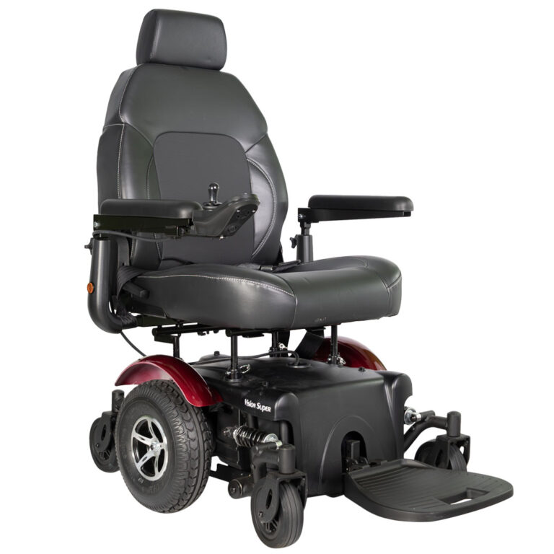

VISION SPORT P327
Features:
- True mid-wheel drive: 20.7” turning radius
- Robust independent suspension can absorb up to 350 lbs on the footplate without tipping forward
- Premium, semi-reclining ergonomic seat, up to 135°
- 12” knobby drive tires for superior traction
- Dynamic LiNX & Shark controller for convenient Bluetooth programming and diagnostics
- 20” seat width with 18”-20” depth adjustability
- 22” or 24” seat widths with 20”-22” depth adjustability

﻿Product # | P327 , P3274 w/lift
Drivetrain | MWD
Seat Width | P327: 22", P3274: 20”
Backrest Height | 22"
Elevating Seat | P3274 - 10"
Overall Width | 27.2"
Turning Radius | 21"
Total Weight | 243 lbs, 273 lbs
Max Speed | 5 mph
Motor | DC 24V, 300W x 2pcs
Battery Size (2) | 12V/22NF (50AH)
Gradient | 8 °
Drive Wheels | 12" flat-free
Group | Group 2: Heavy Duty
HCPCS Code | K0824/K0825 K0830/K0831

As the ordering physician I approve the above described item as appropriate for the patient’s needs.

DOCTOR’S INFORMATION.

Doctor’sSignature:____________________________________________________Date:_____________
Print Name:______________________________________________ NPI#:________________________
Facility Name:_________________________________________________________________________
Address:______________________________________________________________________________
Phone: __________________________________________
Fax: ____________________________________________

